1. **About CSS :-**

* CSS is the language we use to style a Web page.
* CSS stands for Cascading Style Sheets
* CSS describes how HTML elements are to be displayed on screen, paper, or in other media
* CSS saves a lot of work. It can control the layout of multiple web pages all at once
* External stylesheets are stored in CSS files

## Why Use CSS?

CSS is used to define styles for your web pages, including the design, layout and variations in display for different devices and screen sizes.

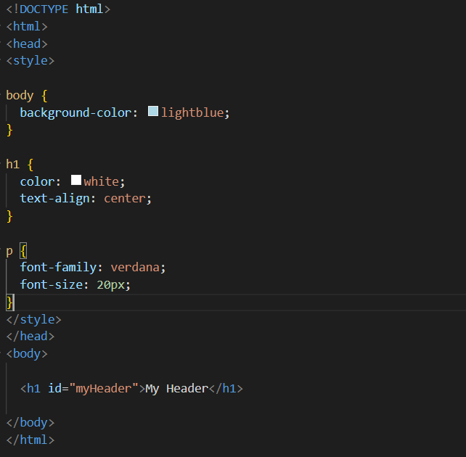

## CSS Syntax :-

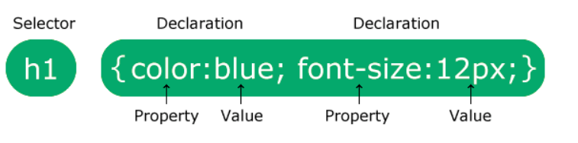

* A CSS rule consists of a selector and a declaration block.
* The selector points to the HTML element you want to style.
* The declaration block contains one or more declarations separated by semicolons.
* Each declaration includes a CSS property name and a value, separated by a colon.
* Multiple CSS declarations are separated with semicolons, and declaration blocks are surrounded by curly braces.

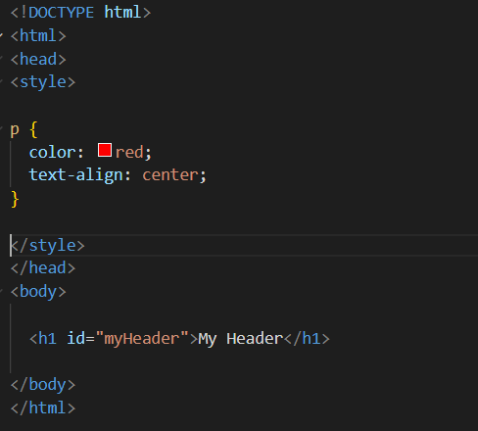

#### Example Explained

* p is a element selector in CSS (it points to the HTML element you want to style: <p>).
* color is a property, and red is the property value
* text-align is a property, and center is the property value

## CSS Selectors :-

CSS selectors are used to "find" (or select) the HTML elements you want to style.

We can divide CSS selectors into five categories:

* Simple selectors (select elements based on name, id, class)
* [Combinator selectors](https://www.w3schools.com/css/css_combinators.asp) (select elements based on a specific relationship between them)
* [Pseudo-class selectors](https://www.w3schools.com/css/css_pseudo_classes.asp) (select elements based on a certain state)
* [Pseudo-elements selectors](https://www.w3schools.com/css/css_pseudo_elements.asp) (select and style a part of an element)
* [Attribute selectors](https://www.w3schools.com/css/css_attribute_selectors.asp) (select elements based on an attribute or attribute value)

This page will explain the most basic CSS selectors.

## The CSS id Selector :-

The id selector uses the id attribute of an HTML element to select a specific element.

The id of an element is unique within a page, so the id selector is used to select one unique element!

To select an element with a specific id, write a hash (#) character, followed by the id of the element.

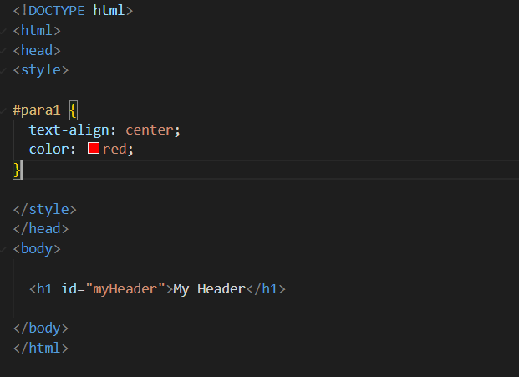

## The CSS class Selector :-

The class selector selects HTML elements with a specific class attribute.

To select elements with a specific class, write a period (.) character, followed by the class name.

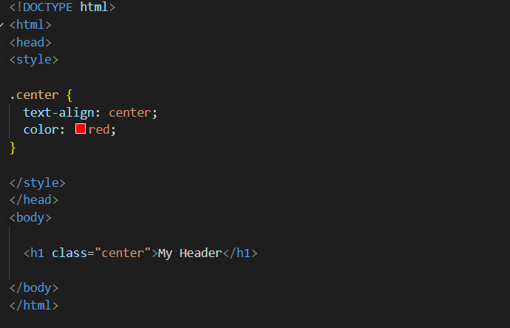

## The CSS Universal Selector :-

The universal selector (*) selects all HTML elements on the page.

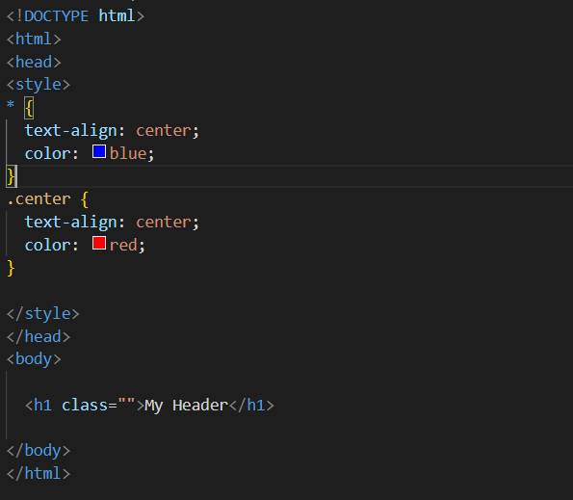

## The CSS Grouping Selector :-

The grouping selector selects all the HTML elements with the same style definitions.

Look at the following CSS code (the h1, h2, and p elements have the same style definitions):

It will be better to group the selectors, to minimize the code.

To group selectors, separate each selector with a comma.

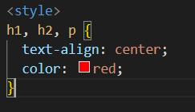

## CSS Comments :-

Comments are used to explain the code, and may help when you edit the source code at a later date.

Comments are ignored by browsers.

A CSS comment is placed inside the <style> element, and starts with /* and ends with */:

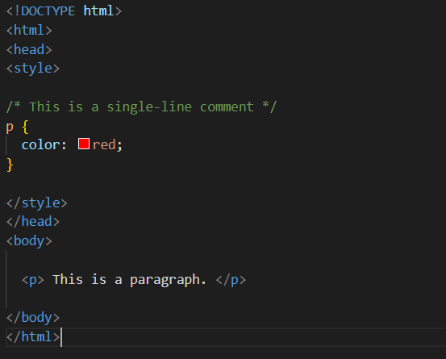

# CSS Colors :-

# Colors are specified using predefined color names, or RGB, HEX, HSL, RGBA, HSLA values.

## CSS Color Names :-

In CSS, a color can be specified by using a predefined color name:

# 

## CSS Text Color :-

You can set the color of text:

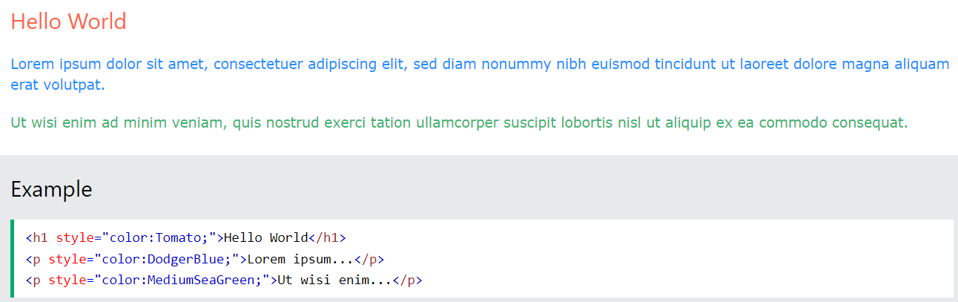 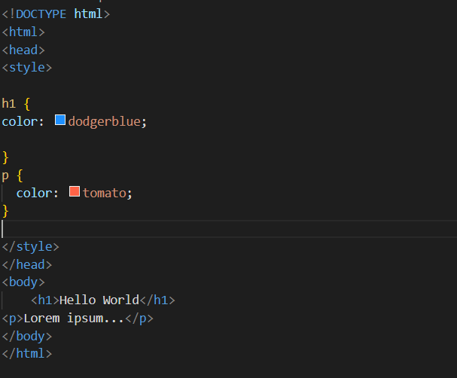

# CSS Backgrounds :-

The CSS background properties are used to add background effects for elements.

## CSS Background Color :-

You can set the background color for HTML elements:

# 

# 

## CSS background-image

The background-image property specifies an image to use as the background of an element.

By default, the image is repeated so it covers the entire element.

The background image can also be set for specific elements, like the <p> element:

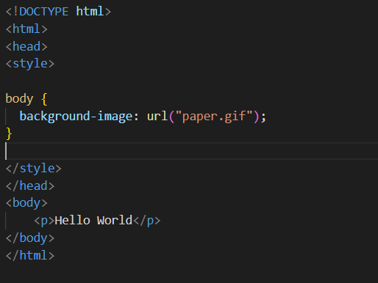 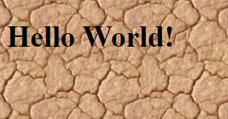

## CSS background-repeat :-

By default, the background-image property repeats an image both horizontally and vertically.

Some images should be repeated only horizontally or vertically, or they will look strange, like this:

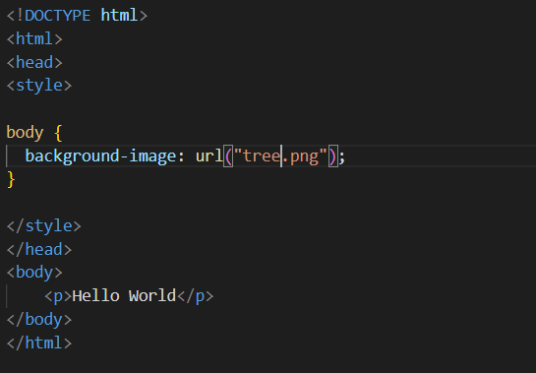 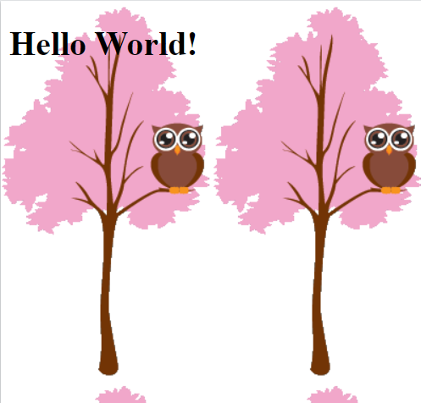

## CSS background-repeat: no-repeat :-

Showing the background image only once is also specified by the background-repeat property:

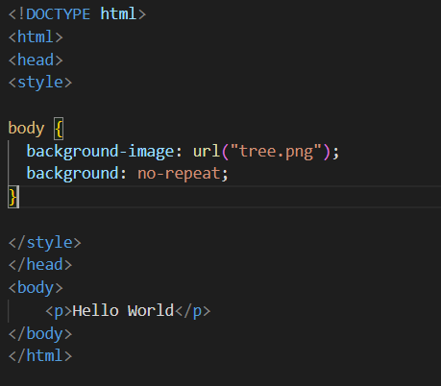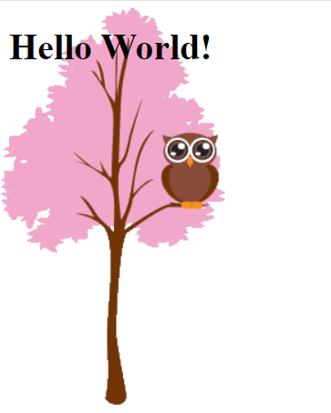

## CSS background-position :-

The background-position property is used to specify the position of the background image.

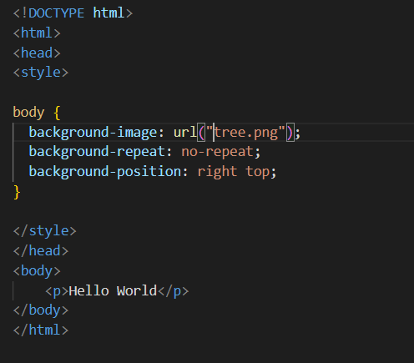

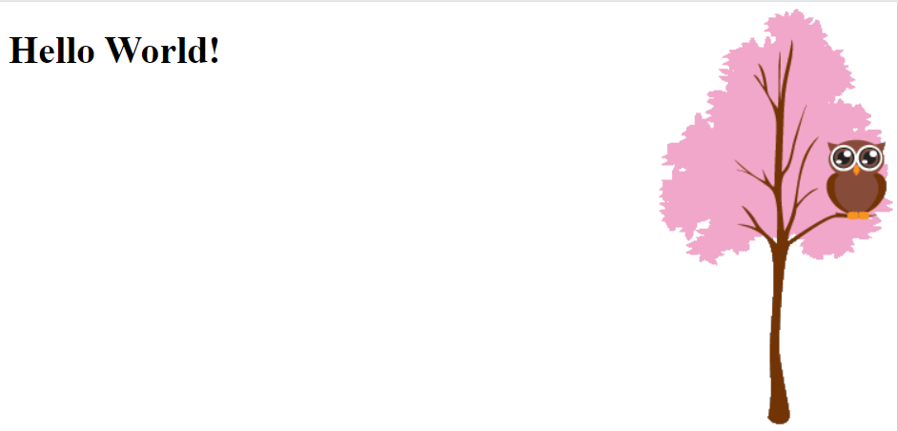

# CSS Borders :-

# The CSS border properties allow you to specify the style, width, and color of an element's border.



## CSS Border Style :-

The border-style property specifies what kind of border to display.

The following values are allowed:

* dotted - Defines a dotted border
* dashed - Defines a dashed border
* solid - Defines a solid border
* double - Defines a double border
* groove - Defines a 3D grooved border. The effect depends on the border-color value
* ridge - Defines a 3D ridged border. The effect depends on the border-color value
* inset - Defines a 3D inset border. The effect depends on the border-color value
* outset - Defines a 3D outset border. The effect depends on the border-color value
* none - Defines no border
* hidden - Defines a hidden border

The border-style property can have from one to four values (for the top border, right border, bottom border, and the left border).

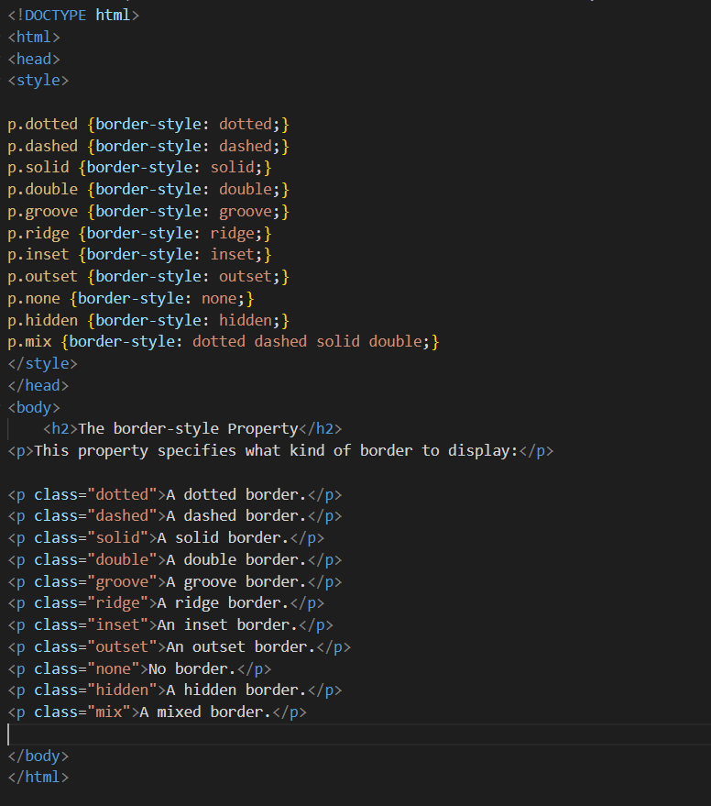 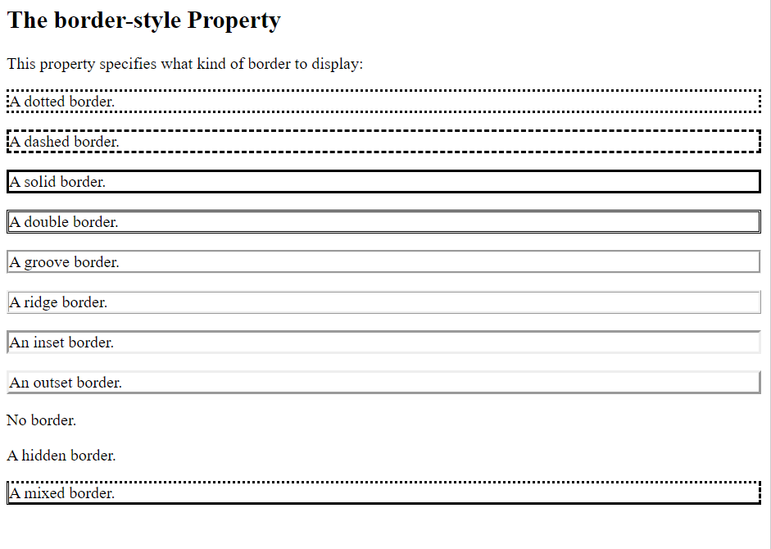

## CSS Border Width :-

The border-width property specifies the width of the four borders.

The width can be set as a specific size (in px, pt, cm, em, etc) or by using one of the three pre-defined values: thin, medium, or thick:

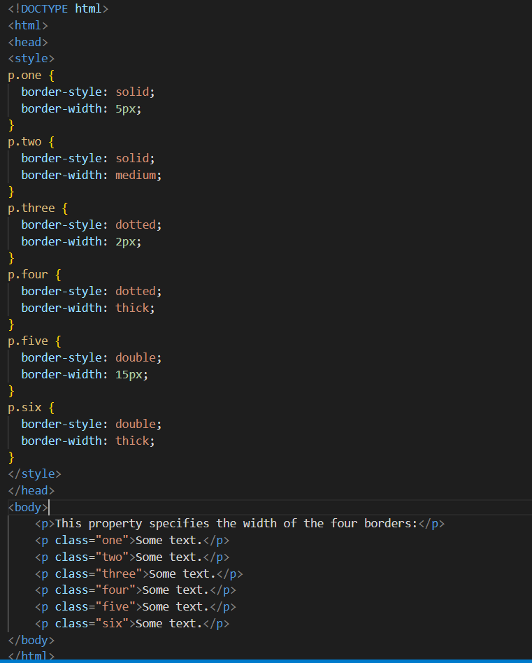

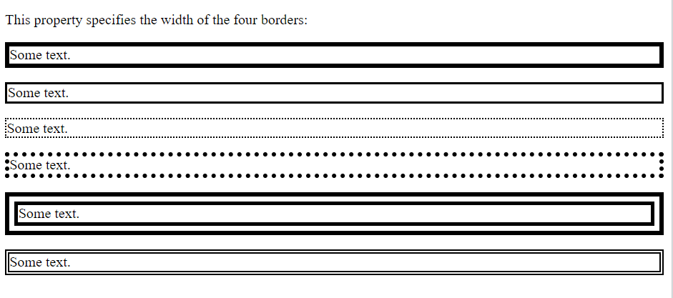

## CSS Border Color :-

You can set the color of borders:

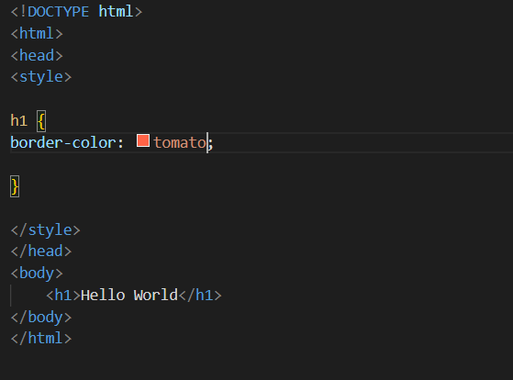

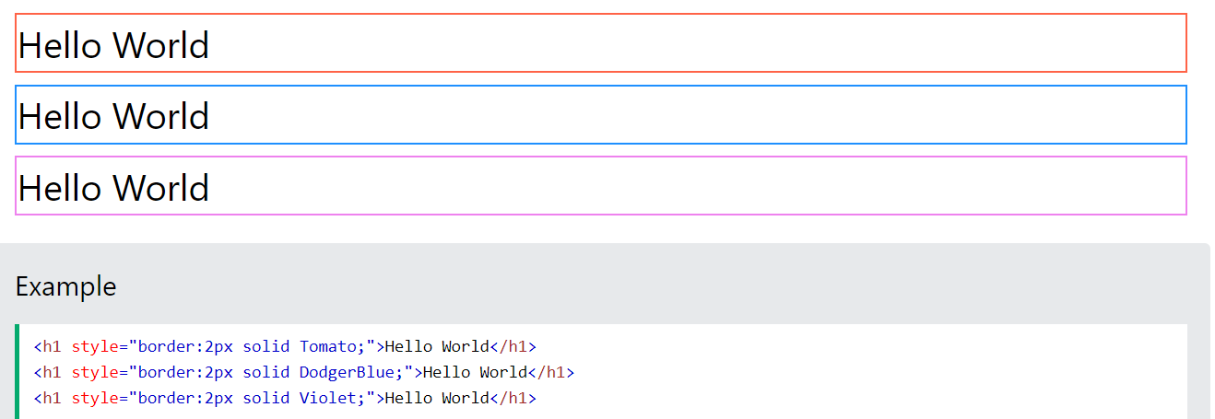

## CSS Margins :-

The CSS margin properties are used to create space around elements, outside of any defined borders.

With CSS, you have full control over the margins. There are properties for setting the margin for each side of an element (top, right, bottom, and left).

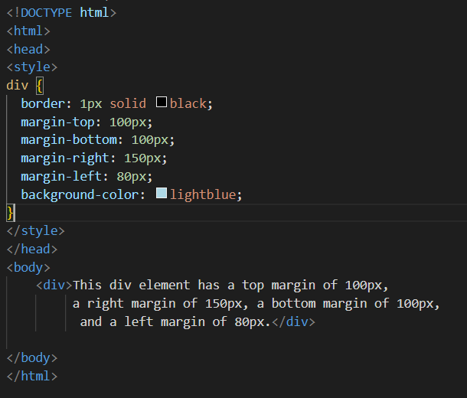 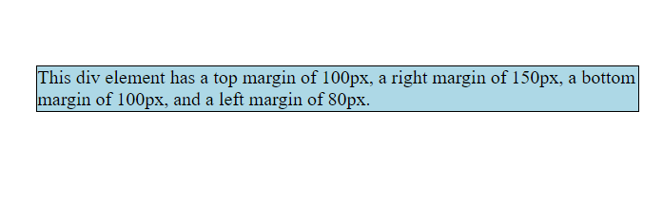

## CSS Padding :-

The CSS padding properties are used to generate space around an element's content, inside of any defined borders.

With CSS, you have full control over the padding. There are properties for setting the padding for each side of an element (top, right, bottom, and left).

CSS has properties for specifying the padding for each side of an element:

* padding-top
* padding-right
* padding-bottom
* padding-left

All the padding properties can have the following values:

* *length* - specifies a padding in px, pt, cm, etc.
* *%* - specifies a padding in % of the width of the containing element
* inherit - specifies that the padding should be inherited from the parent element

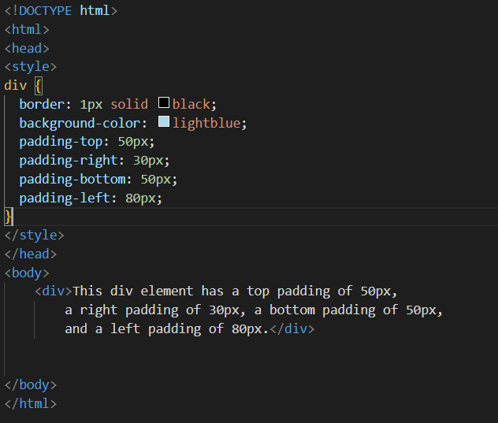

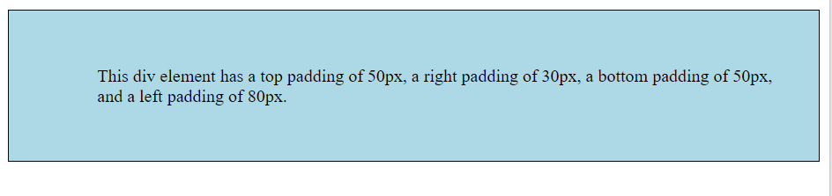

## CSS height and width Values :-

The height and width properties may have the following values:

* auto - This is default. The browser calculates the height and width
* length - Defines the height/width in px, cm, etc.
* % - Defines the height/width in percent of the containing block
* initial - Sets the height/width to its default value
* inherit - The height/width will be inherited from its parent value

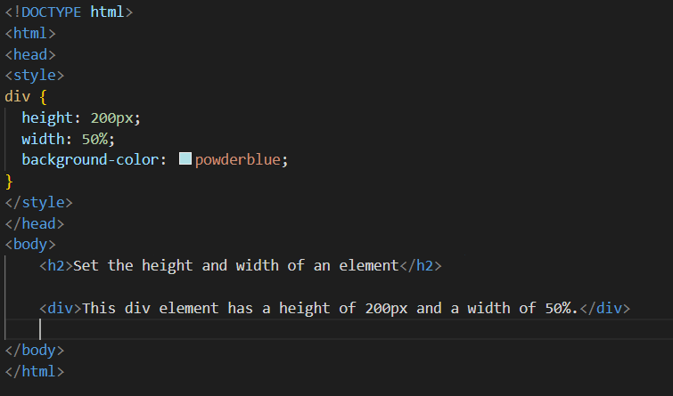 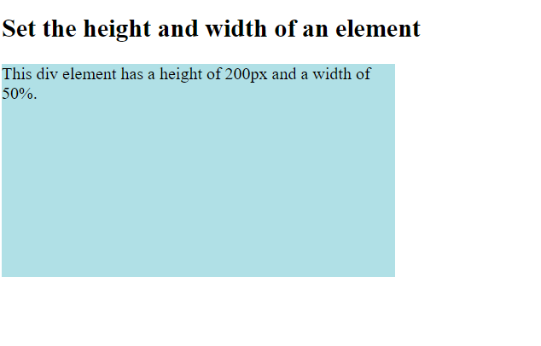

# CSS Icons :-

* The simplest way to add an icon to your HTML page, is with an icon library, such as Font Awesome.
* Add the name of the specified icon class to any inline HTML element (like <i> or <span>).
* All the icons in the icon libraries below, are scalable vectors that can be customized with CSS (size, color, shadow, etc.)

  
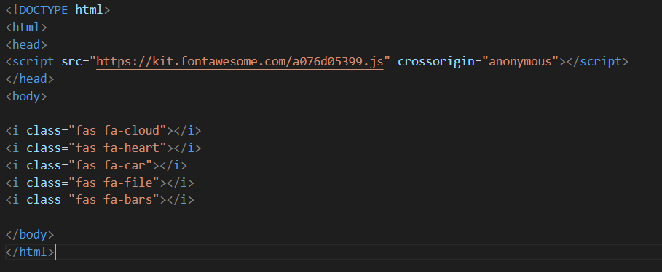

## HTML Lists and CSS List Properties :-

In HTML, there are two main types of lists:

* unordered lists (<ul>) - the list items are marked with bullets
* ordered lists (<ol>) - the list items are marked with numbers or letters

The CSS list properties allow you to:

* Set different list item markers for ordered lists
* Set different list item markers for unordered lists
* Set an image as the list item marker
* Add background colors to lists and list items

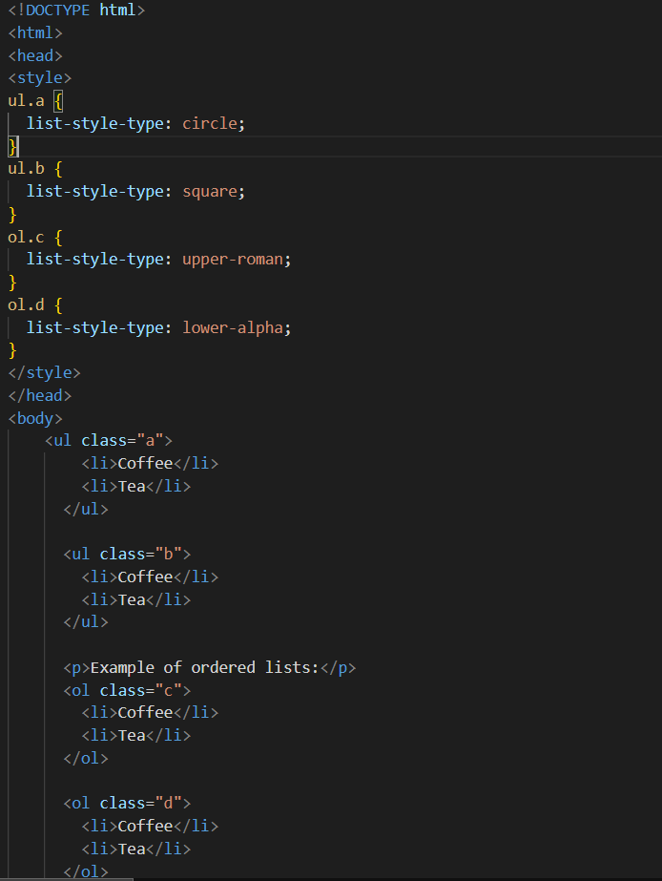 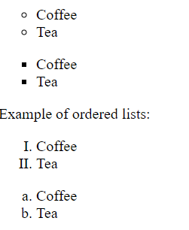

# CSS Forms :-

# The look of an HTML form can be greatly improved with CSS:-

## Styling Input Fields :-

Use the width property to determine the width of the input field:

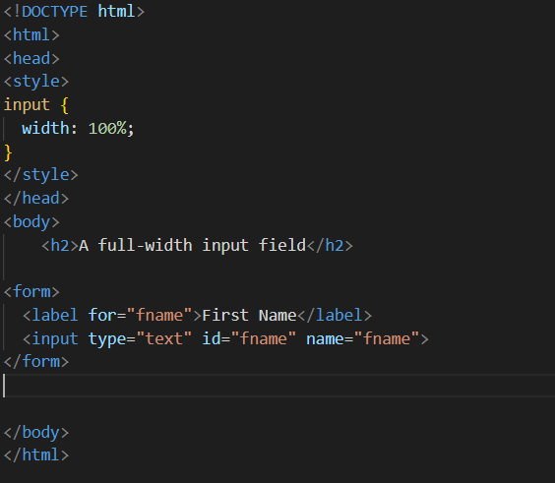

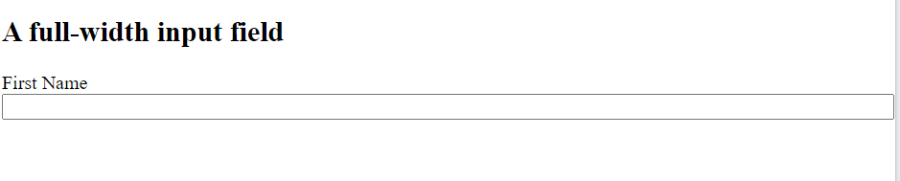

**NOTE :- As shown in the above example you can apply various CSS styles to the HTML form for the all the various elements present in the body of the form.**

# CSS Gradients :-

CSS gradients let you display smooth transitions between two or more specified colors.

CSS defines three types of gradients:

* Linear Gradients (goes down/up/left/right/diagonally)
* Radial Gradients (defined by their center)
* Conic Gradients (rotated around a center point)

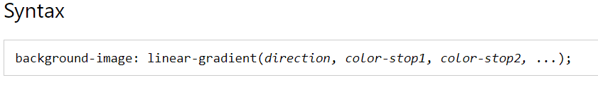

# 

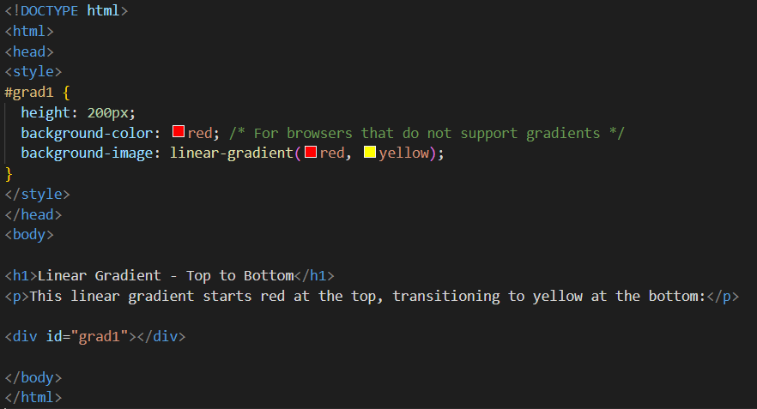

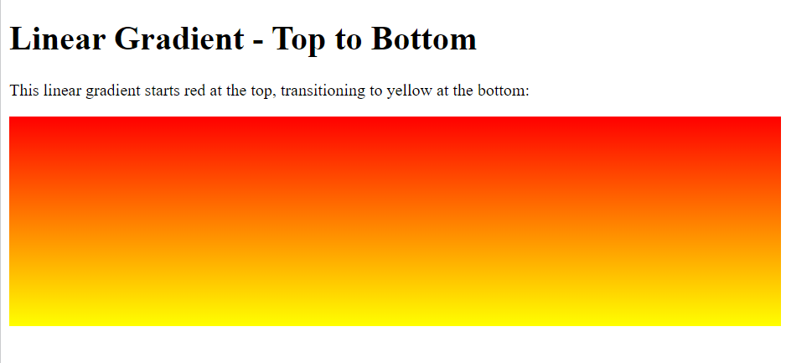

## CSS Transitions :-

CSS transitions allows you to change property values smoothly, over a given duration.

* transition
* transition-delay
* transition-duration
* transition-property
* transition-timing-function

To create a transition effect, you must specify two things:

* the CSS property you want to add an effect to
* the duration of the effect

**Note:** If the duration part is not specified, the transition will have no effect, because the default value is 0.

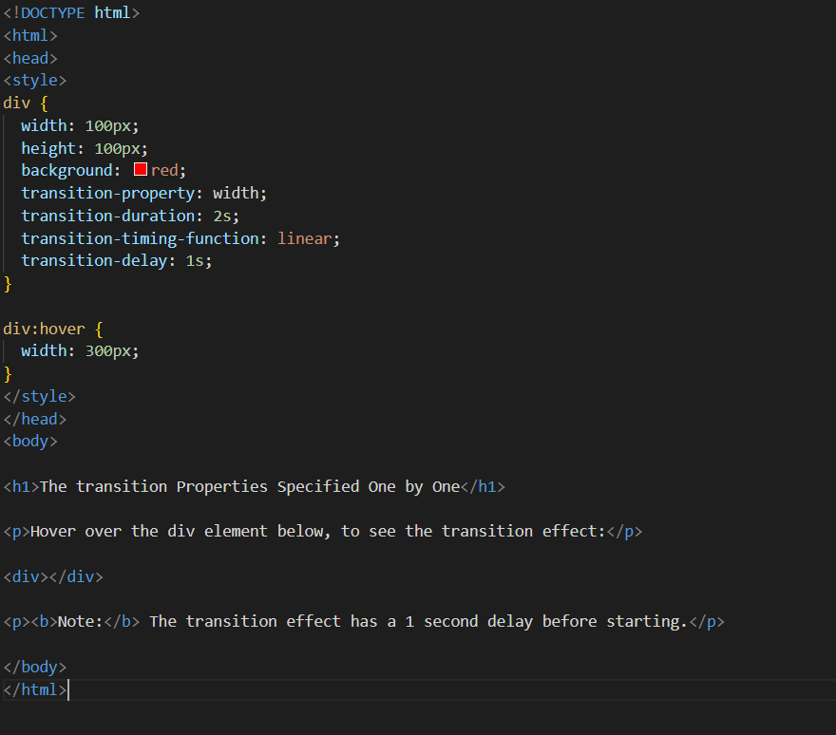

**NOTE :- Write the following code in your VS Code to see the transition .**

## CSS Animations :-

CSS allows animation of HTML elements without using JavaScript or Flash!

* @keyframes
* animation-name
* animation-duration
* animation-delay
* animation-iteration-count
* animation-direction
* animation-timing-function
* animation-fill-mode
* animation

An animation lets an element gradually change from one style to another.You can change as many CSS properties you want, as many times as you want.

To use CSS animation, you must first specify some keyframes for the animation.Keyframes hold what styles the element will have at certain times.

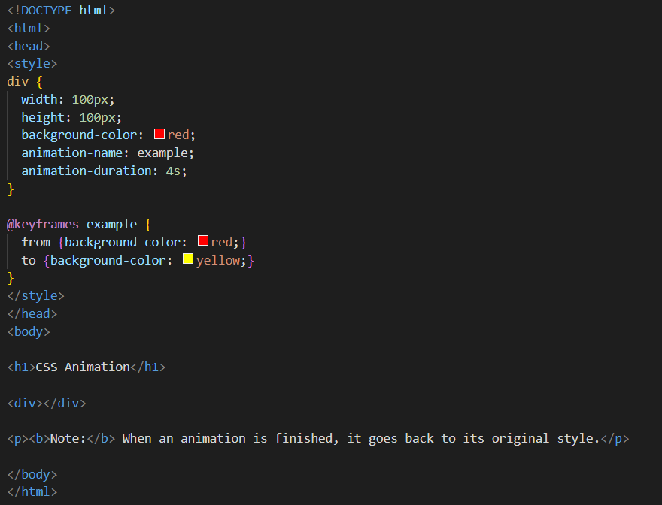

**NOTE :- Write the following code in your VS Code to see the animation.**